TERM WORK III

MOVIE DATABASE

Consider the schema for MovieDatabase:

ACTOR (Act_id, Act_Name, Act_Gender)

DIRECTOR (Dir_id, Dir_Name,Dir_Phone)

MOVIES (Act_id,Mov_id, Mov_Title, Mov_Year, Mov_Lang,Dir_id)

MOVIE_CAST (Act_id, Mov_id, Role)

RATING (Mov_id,Rev_Stars)

**1.** Draw ER and schema diagram for database.

**2.**Create the above tables by properly specifying the primary keys and foreign keys.

**3.** Enter at least five tuples for each relation.

**4.**List the titles of all movies directed by‘Hitchcock’.

**5.**Find the maximum rating of movie

**6.**Display names of actors acted in more than one movie.

**7.** List all actors who acted in a movie between 2000 and 2015

**8.** Update rating of all movies directed by ‘Steven Spielberg’ to5.

**1.**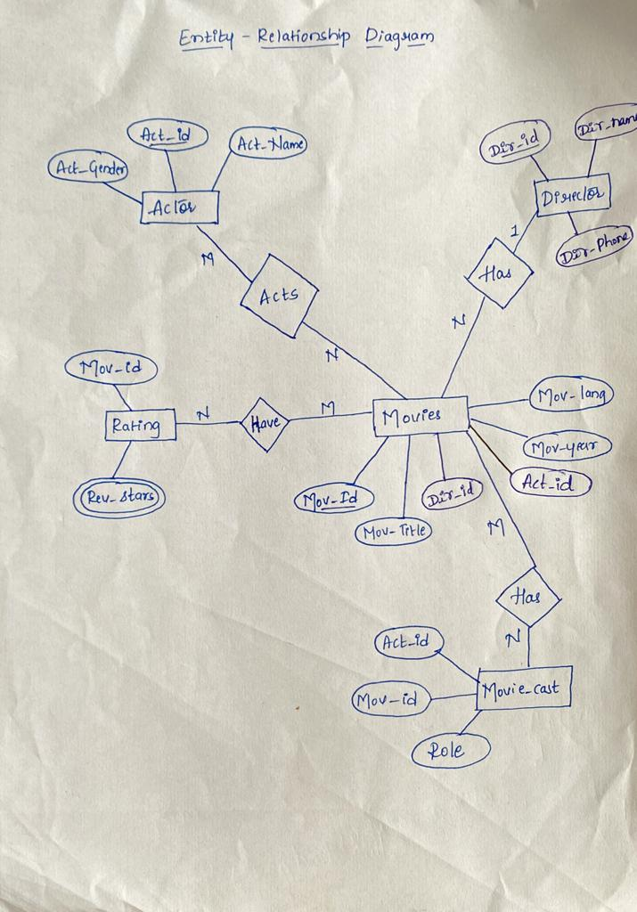

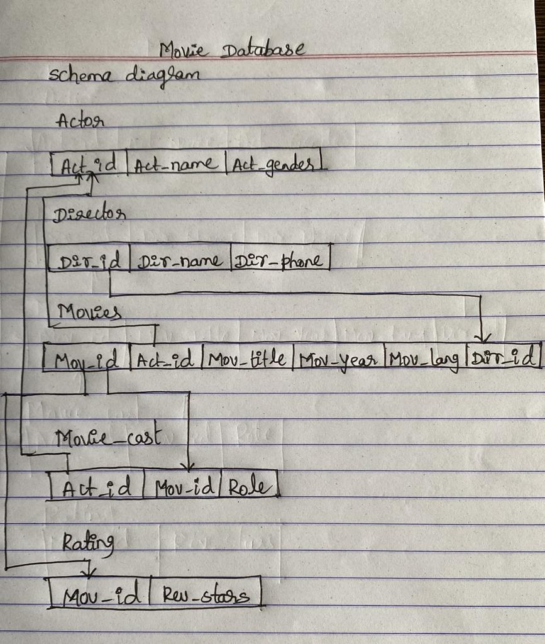

**2.Table Creation**

create table actor (

act_id number (3)primary key,

act_name varchar (20),

act_gender char (1));

create table director (

dir_id number (3)primary key,

dir_name varchar (20),

dir_phone number (10));

create table movies (

mov_id number (4)primary key,

act_idnumber (3),

mov_title varchar (25),

mov_year number (4),

mov_lang varchar (12),

dir_id number (3),

foreign key (act_id) references actor (act_id),

foreign key (dir_id) references director (dir_id));

create table movie_cast (

act_idnumber (3),

mov_idnumber(4),

role varchar(10),

foreign key (act_id) references actor (act_id),

foreign key(mov_id) references movies (mov_id));

create table rating (

mov_id number (4)references movies (mov_id),

rev_stars varchar (25),

);

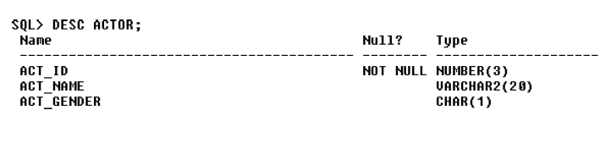

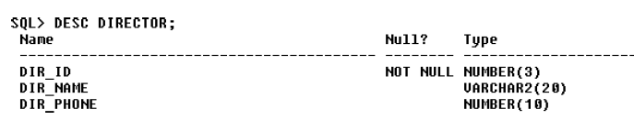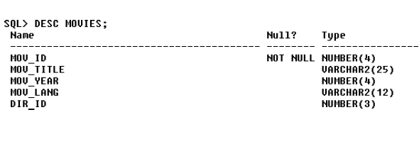

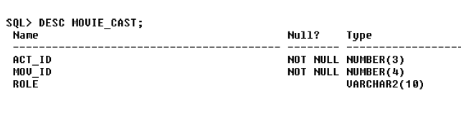

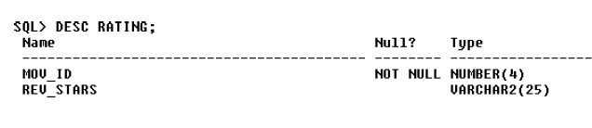

**3. Insertion of Values to Tables**

insert into actor values (301,‘anushka‘,‘f‘);

insert into actor values (302,‘prabhas‘,‘m‘);

insert into actor values (303,‘punith‘,‘m‘);

insert into actor values (304,‘jermy‘,‘m‘);

insert into director values (60,‘rajamouli‘, 8751611001);

insert into director values (61,‘hitchcock‘, 7766138911);

insert into director values (62,‘faran‘, 9986776531);

insert into director values (63,‘steven spielberg‘, 8989776530);

insert into movies values (1001,‘bahubali-2‘, 2017, telagu‘, 60);

insert into movies values (1002,‘bahubali-1‘, 2015, telagu‘, 60);

insert into movies values (1003,‘akash‘, 2008, kannada‘, 61);

insert into movies values (1004,‘war horse‘, 2011, english‘, 63);

insert into movie_cast values (301, 1002, heroine‘);

insert into movie_cast values (301, 1001, heroine‘);

insert into movie_cast values (303, 1003, hero‘);

insert into movie_cast values (303, 1002, guest‘);

insert into movie_cast values (304, 1004, hero‘);

insert into rating values (1001,4);

insert into rating values (1002,2);

insert into rating values (1003, 5);

insert into rating values (1004, 4);

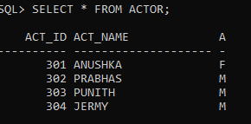

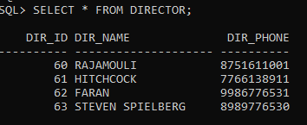

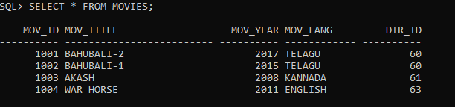

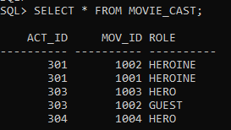

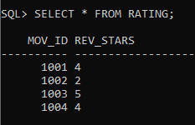

1. **List the titles of all movies directed by‘Hitchcock’.**

select mov_title from movies m,director d

where m.dir_id=d.dir_id and

dir_name= ‘hitchcock’;

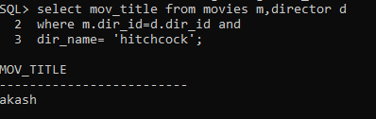

1. **Find the maximum rating of movie**

select m.mov_id,m.mov_title,r.rev_stars

from movies m,rating r where

m.mov_id=r.mov_id and rev_starsin(select max(rev_stars) from rating);

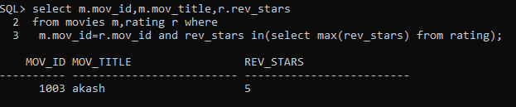

1. **Display names of actors acted in more than one movie.**

select a.act_name,count(*) as N_of_movies_acted from actor a,movies m

where a.act_id=m.act_id group by a.act_name having count(*)>1;

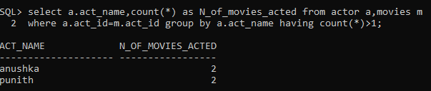

1. **List all actors who acted in a movie between 2000 and 2015**

select distinct(m.mov_year),a.act_name,m.mov_title

from actor a,movies m

where a.act_id=m.act_id and mov_year

between 2000 and 2015;

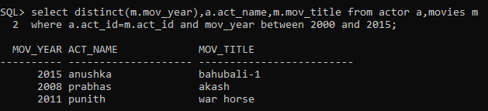

**8.Update rating of all movies directed by ‘Steven Spielberg’ to5**

update rating

set rev_stars=5

where mov_id in (select mov_id from movies where dir_id in

(select dir_idfrom director

where dir_name ='stevenspielberg'));

